**CHE 524 Process Control Laboratory**

**Group 1 – Prelab for MVCU**

**Daniel Cho, Ishraq Habib, Mohammad Suria**

This lab we performed close loop system identification using Matlab and transfer function. Assuming that the system fit a first order a first order response.

And we use a PI controller,

We develop a transfer function and used lsqcurvefit to find the process parameter and .

**Close loop System Identification**

Since this experiment is conducted in close loop condition, We need a new model to describe system behavior.

has the form of

Using Matlab symbolic math tool box,

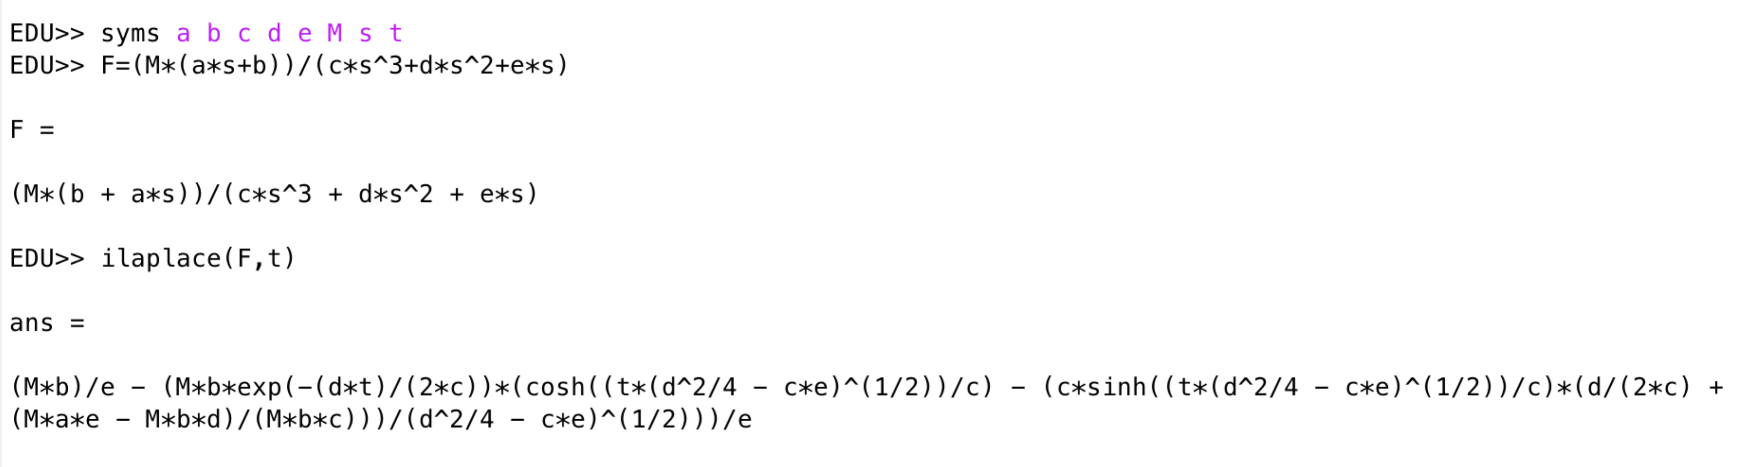

Adding appropriate symbol for element and element multiplication, we obtained formula X, a time domain model that describes PI and first order (PIAFO) behaviour.

X=(M.*b)/e - (M.*b.*exp(-(d.*t)./(2.*c)).*(cosh((t.*(d.^2/4 - c.*e).^(1/2))/c) - (c.*sinh((t.*(d.^2./4 - c.*e).^(1/2))./c).*(d./(2.*c) + (M.*a.*e - M.*b.*d)/(M.*b.*c)))/(d^2/4 - c.*e)^(1/2)))./e

Comparing F(s) and PIAFO model we obtained,

**Developing a Matlab function for PIAFO model**

A PIFAO Model requires the knowledge of time (s), step change (M), control gain (Kc), control integrative action (, process gain (Kp), process time constant (

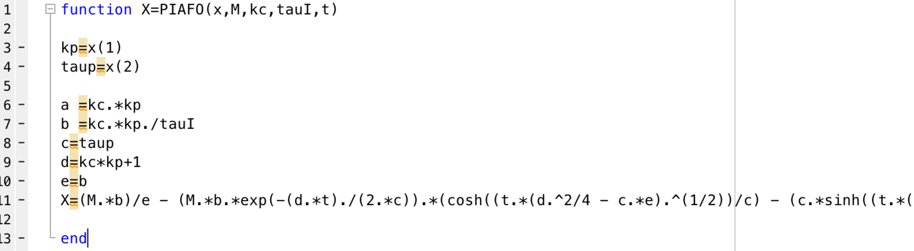

We have the knowledge of all except process gain and process time delay. In order to use optimization algorithm to solve for them, we put Kp and taup in a column vector x where x is

We want to use lsqcurvefit to solve for Kp and taup. See appendix for the full Matlab script. The script is explained below.

The function takes the following form:

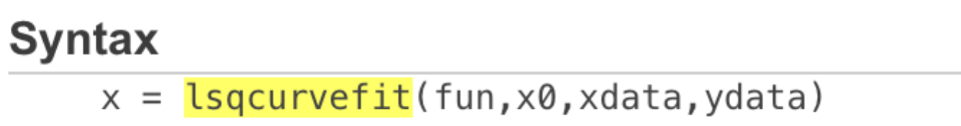

where fun is the model we want to fit using function handle. X0 is the initial guess for vector x, xdata is the independent variables and ydata is the dependent variable. Since our PIFAO model have many parameters but we are only solving for 2 of them, we use function handle to tell Matlab which parameters we want to solve.

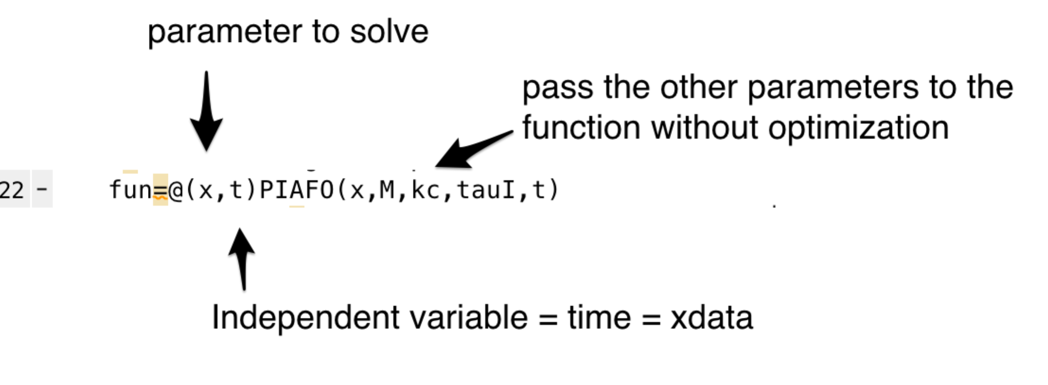

Then we called the lsqcurefit function using our function handle (fun), initial guess where

Which is determined by trial and error.



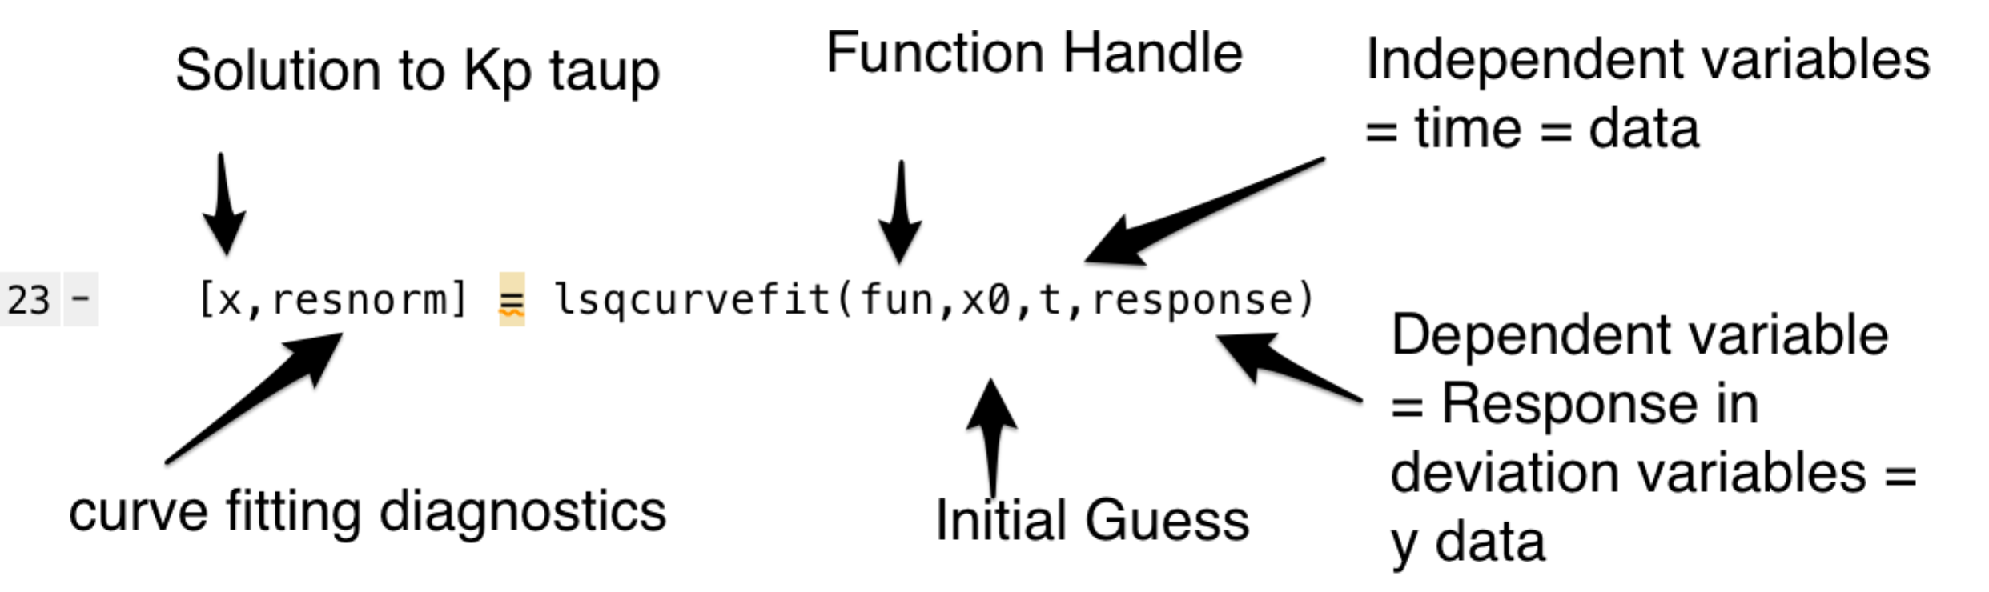

We determined that the software take sample every 6 seconds. Instead of importing time vector every time, we create a column time vector that starts from 0 with increment of 6 until it match the length of the response data.



The response vector, step change, and Kc and , title of the plot are defined in the beginning of the code

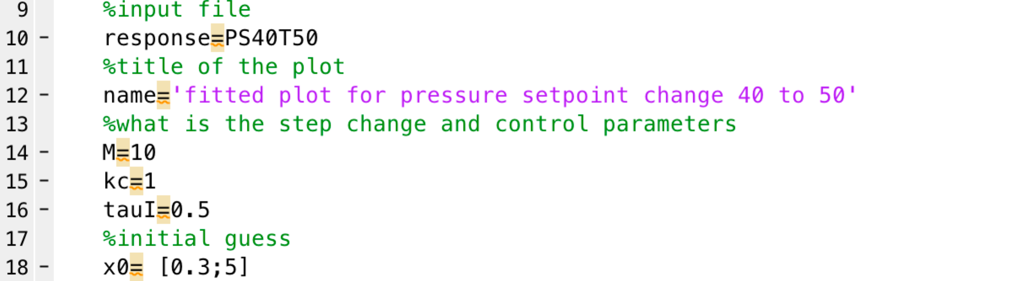

**Result of Close Loop System Identification**

**Flow rate Experiment**

|  |  |  |  |
| --- | --- | --- | --- |
|  | Vector Name | Kp |  |
| Kc = 0.5 | FL20T30 | 0.011 | 2.611 |
| FL30T40 | 0.028 | 0.064 |
| FL40T50 | 0.013 | 4.94 |
| FL50T60 |  |  |
| FL60T40 | 0.033 | 0.056 |
| FL40T20 | 0.013 | 0.14 |
| Kc=0.3 | FL20T30 | 0.012 | 6.826 |
| FL30T40 | 0.023 | 0.089 |
| FL40T50 | 0.041 | 0.06 |
| kc=0.8 | FL20T30 | 0.014 | 0.081 |
| FL30T40 | 0.032 | 0.06 |
| FL40T50 | 0.016 | 0.068 |
| Average |  | 0.021 | 1.363 |
| Standard Deviation |  | 0.010 | 2.396 |
| Upper bound |  | 0.0276 | 2.7793 |
| Lower bound |  | 0.015 | 0.000 |

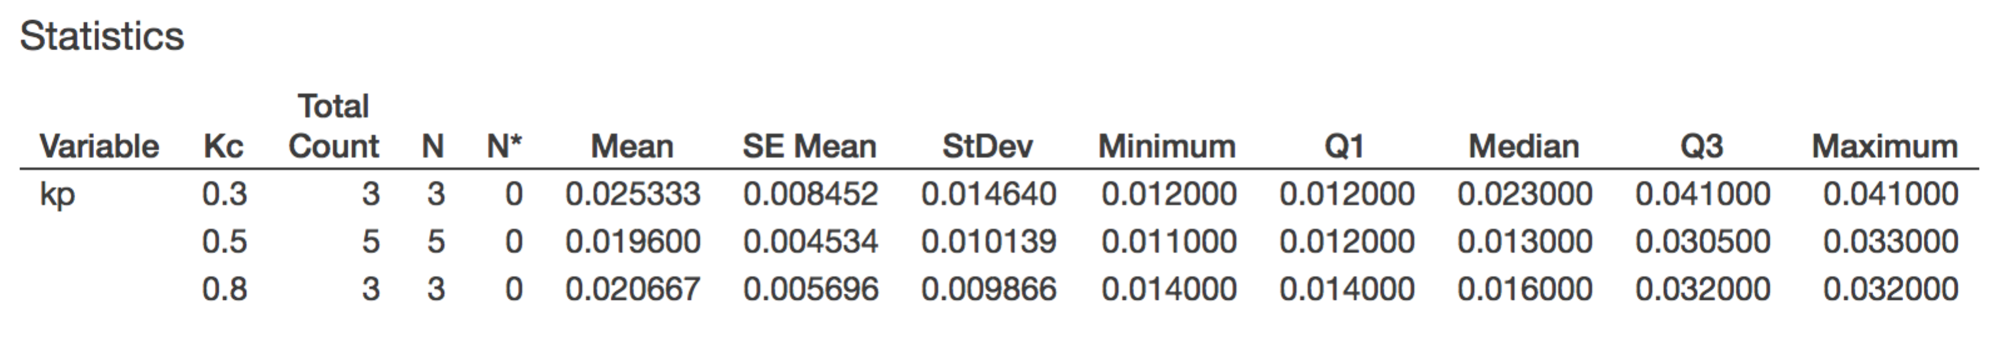

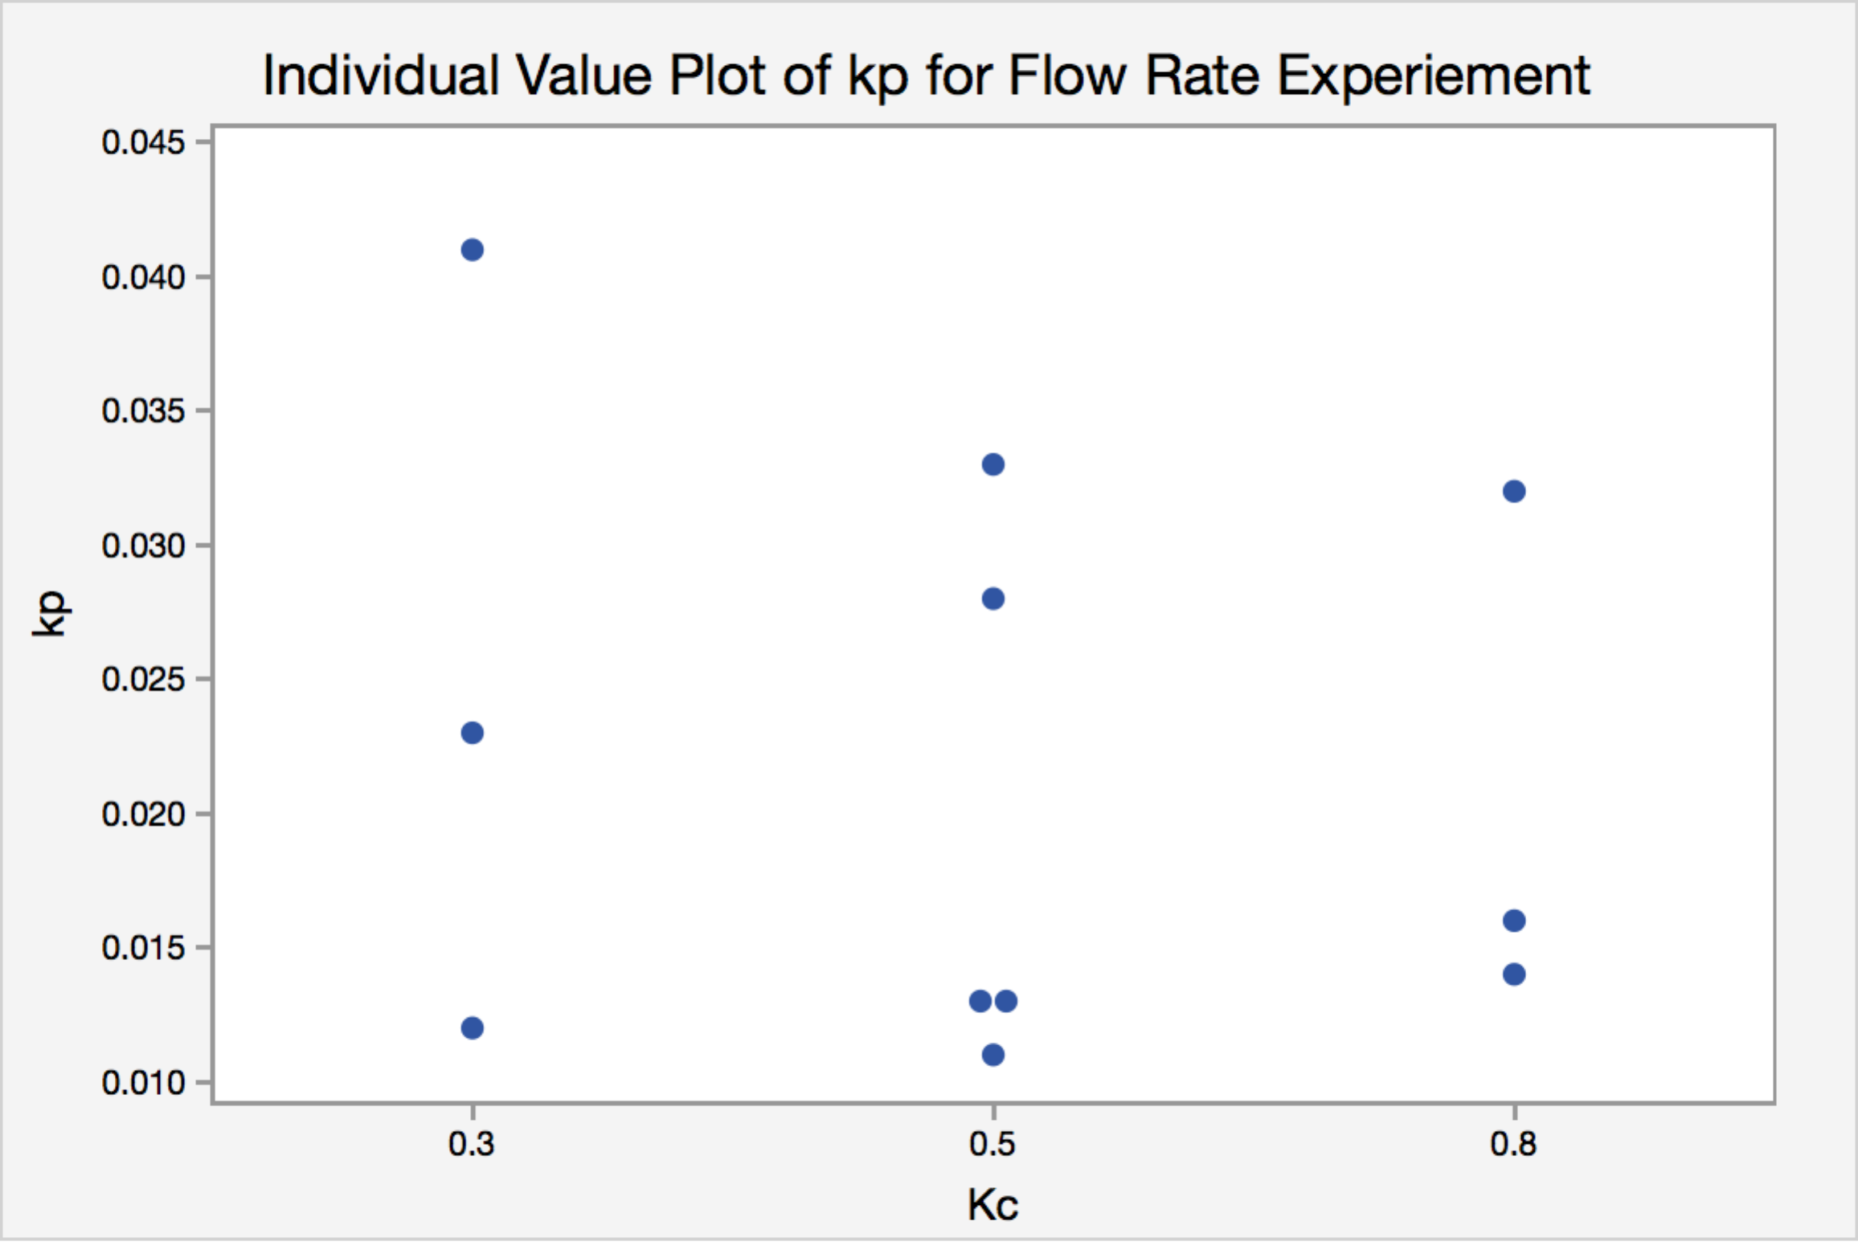

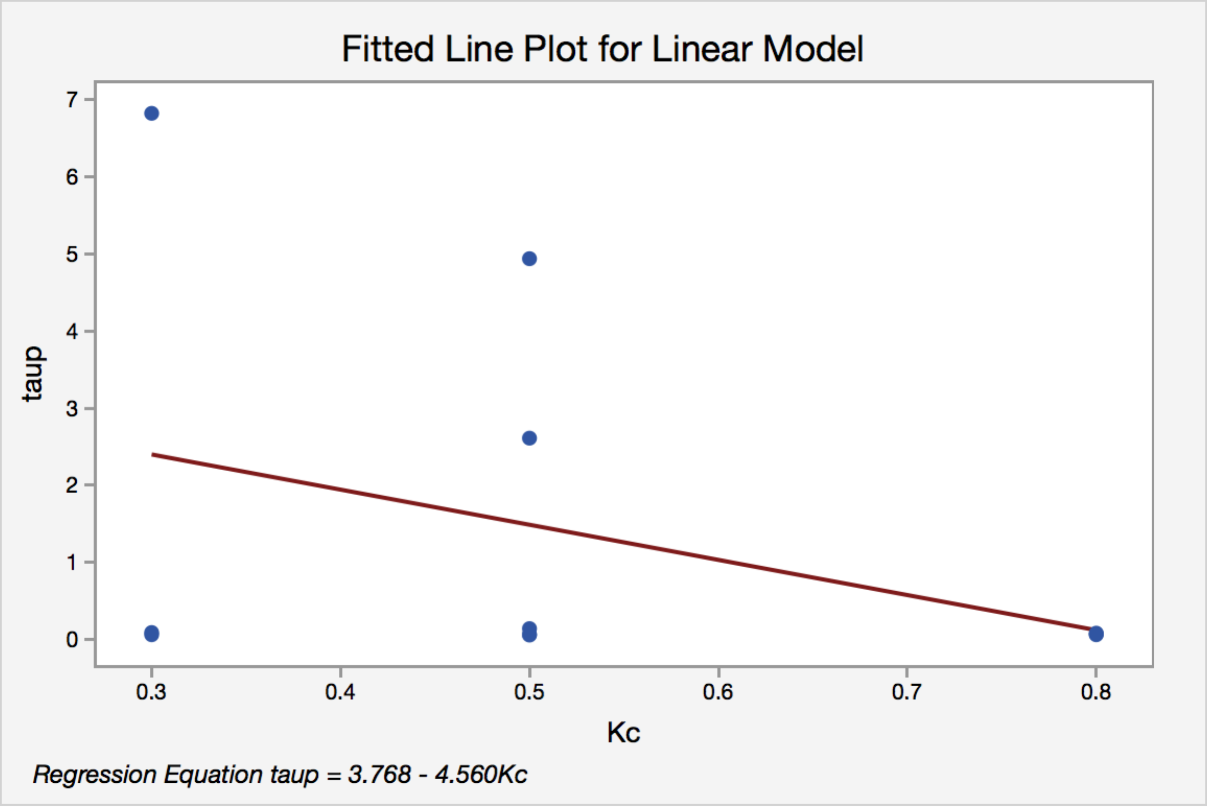

We determined that process gain (Kp) is between 0.015 - 0.0276 and process time constants is between 0~2.77. The average is 0.021 and1.363, respectively. Experiment conducted in low Kc has higher variance than when Kc is high. However, the variation at the 3 conditions is negligible.

**Pressure Experiment**

|  |  |  |  |
| --- | --- | --- | --- |
| tauc=0.5 | Vector Name | kp | taup |
| kc=0.8 | PS20T30 | 0.025 | 0.047 |
| PS30T40 | 0.037 | 5.797 |
| PS40T50 | 0.039 | 0.943 |
| PS50T60 | 0.046 | 3.267 |
| PS60T40 | 0.077 | 2.579 |
| PS40T20 | 0.031 | 5.222 |
| kc=0.6 | PS20T30 | 0.044 | 1.248 |
| PS30T40 | 0.039 | 7.073 |
| PS40T50 | 0.035 | 3.369 |
| kc=1.0 | PS20T30 | 0.063 | 4.46 |
| PS30T40 | 0.05 | 1.823 |
| PS40T50 | 0.056 | 1.557 |
| Avg |  | 0.045 | 3.115 |
| STDEV |  | 0.015 | 2.157 |
| Upper bound | | 0.053 | 4.336 |
| Lower bound | | 0.037 | 1.895 |

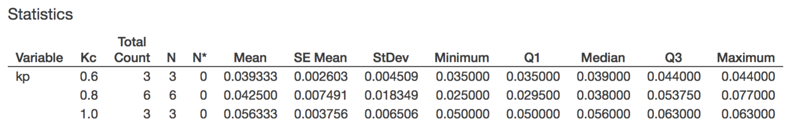

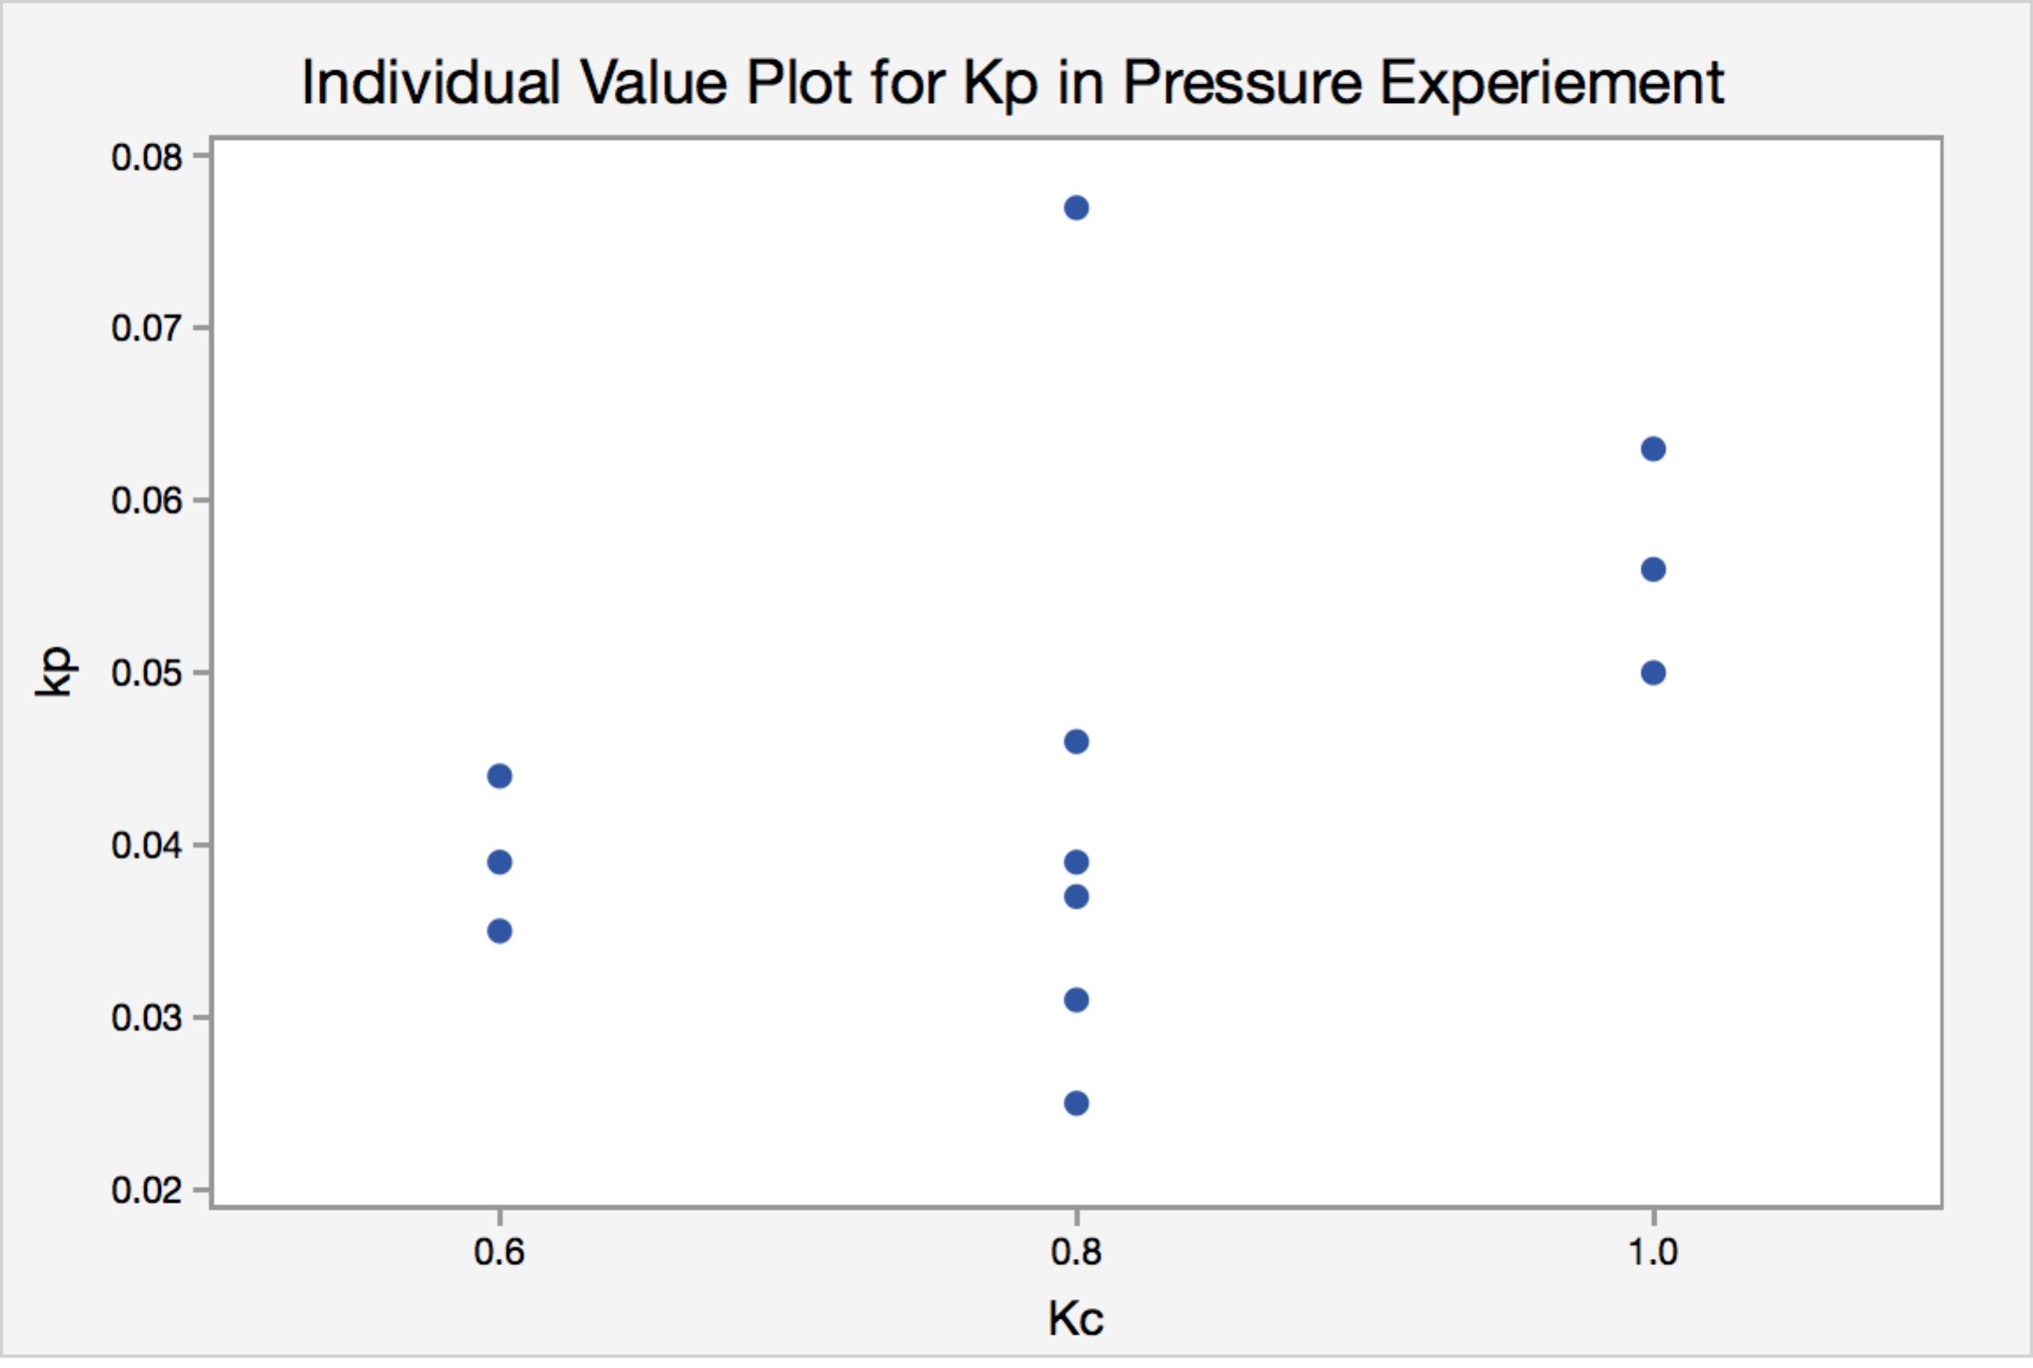

We determined that the process gain for the pressure experiment is between 0.037~0.053, the process time constant is 1.895~4.336. We found that experiment runs at Kc=0.8 have the highest variance and the experiment runs at Kc=1 have the highest average process gain. Estimation of process time constant decreased as Kc increase.

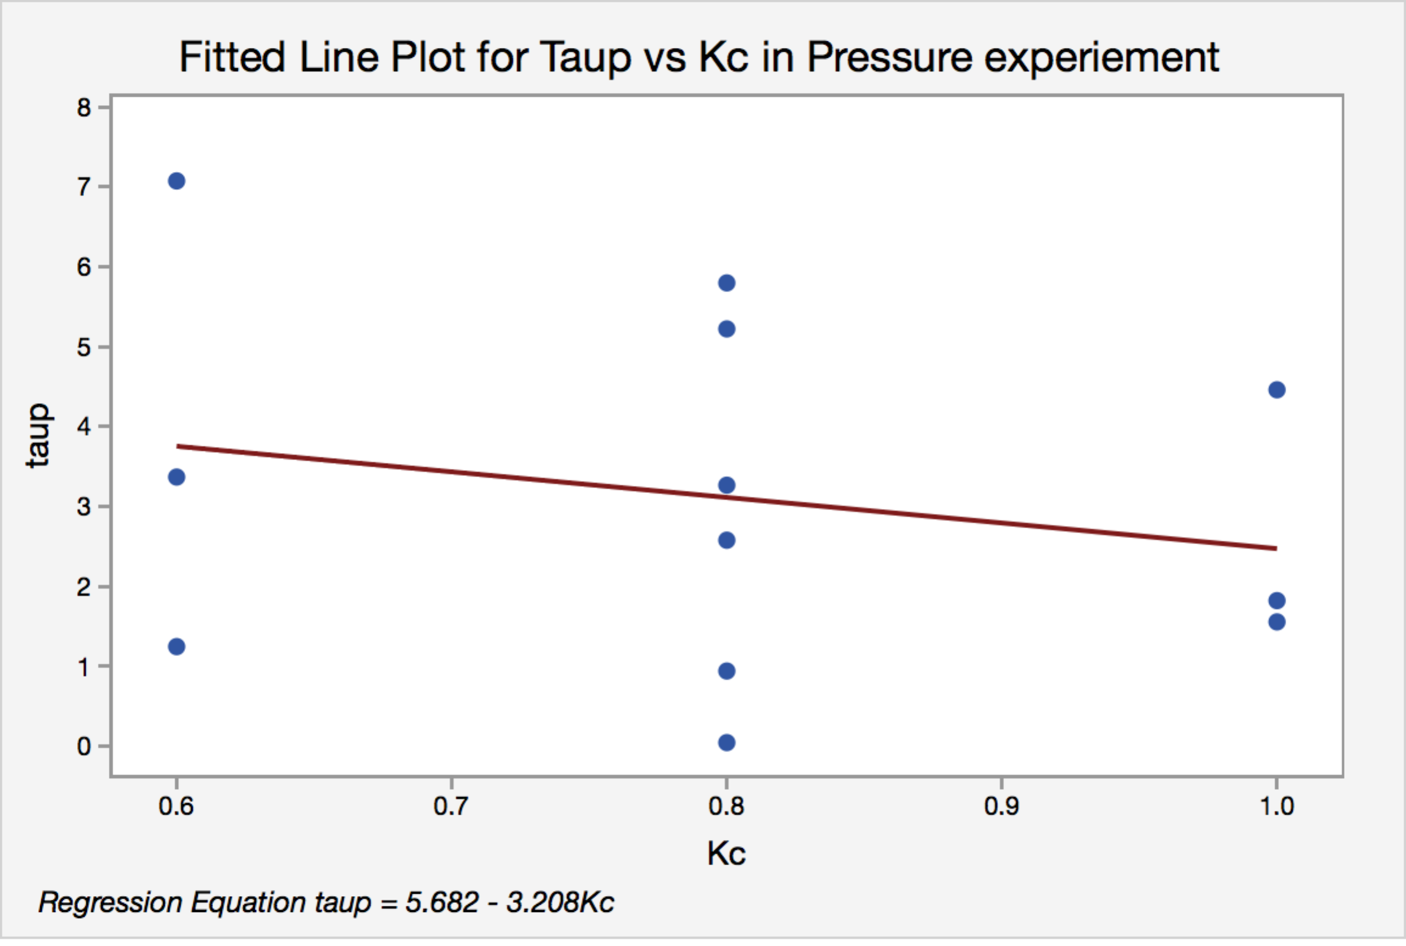

**Conclusion for Close loop System Identification**

For flow rate experiment, we determined that process gain (Kp) is between 0.015 - 0.0276 and process time constants is between 0~2.77. The average is 0.021 and 1.363, respectively.

For pressure MIMO experiment, we determined that the process gain for the pressure experiment is between 0.037~0.053, the process time constant is 1.895~4.336. The average is 0.045 and 3.115, respectively.

We found that for both experiments, Kp are not affected by Kc, but decreases with increasing Kc for both experiment.

**Effect of Chaining Kc**

**Flowrate Experiement**

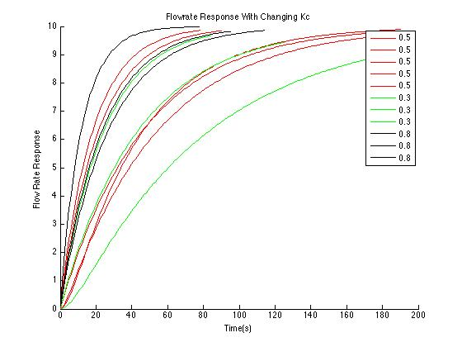

Figure compares all flow rate response with varying Kc. Though the data overlap with each other, it is clear that with increasing Kc, flow rate response are faster, and with lower variance between each runs.

**Pressure Experiment**

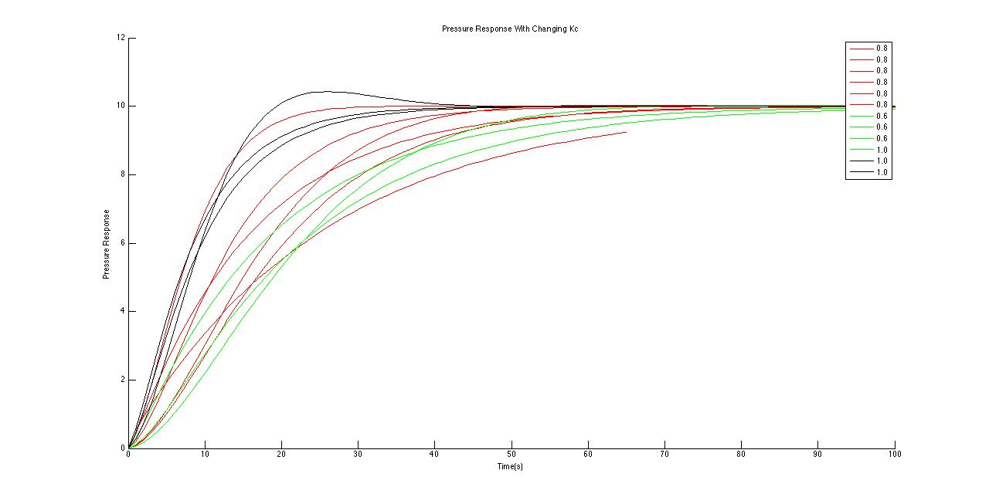

Appendix A

Flow rate experiment

